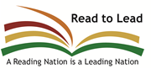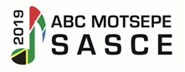

**JOURNALIST AND PHOTOGRAPHER ACCREDITATION FORM FOR**

**ABC MOTSEPE SASCE 25-28 June 2019**

**Rhema Bible Church, Randburg, Johannesburg**

|  |  |
| --- | --- |
| **Name of Journalist:** |  |
| **Name of photographer:** |  |
| **ID Numbers of both Journalist and Photographer (non-negotiable for security purposes)** |  |
| **Media House:** |  |
| **Email address:** |  |
| **Cell Number:** |  |
| **Work Number:** |  |

**Signature: Date:**

**………………………..………… …..……………...**

**PS:** RVSP by Friday, 21 June 2019